

Seeking a challenging position where I can utilize my skills to contribute to the success of the company. To secure a role in a dynamic company that offers opportunities for professional advancement.

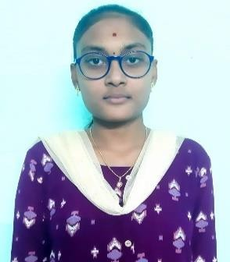

**POTNURU VENKATA SAI KRISHNA MOURYA**

**Email :** [mourya.potnru2003@gmail.com](mailto:mourya.potnru2003@gmail.com)

**Contact** : +91-9014948181

**LinkedIn** : [https//www.linkedin.com/in/mourya-potnuru-559081252](http://www.linkedin.com/in/mourya-potnuru-559081252)



|  |  |  |  |
| --- | --- | --- | --- |
| **Academic Qualification** | **University/Board** | **Year** | **Percentage**  **/CGPA** |
| B.Tech. (CSE) | JNTUGV | 2025 | 8.92  (C.G.P.A) |
| Intermediate | Board of Intermediate Education, AP | 2021 | 91% |
| SSC | Board of Secondary Education, AP | 2019 | 10.0  (C.G.P.A) |



**Programming Known :** C, Java, Python

**Development :** HTML, CSS

**Operating Systems :** Windows

**Tools :** MS-Office



# A NOVEL APPROACH FOR AN EFFICIENT NETWORK INTRUSION DETECTION SYSTEM

This project focuses on an efficient intrusion detection system by combining CNN and CNN with K-means clustering to enhance detection accuracy and interpretability. Deep learning models like CNN offer lower accuracy, lack of interpretability making it difficult to understand while certain traffic is classified as normal or malicious, CNN with K-means clustering out performs the higher accuracy and better handling of minority classes. The effective of combining deep learning with clustering for improved intrusion detection.

**Title :** UI&UX **Organization :** Infinitech Soft LLP **Duration :** 30 Days

**Location :** Kukatpally, Hyderabad

A UI/UX designer creates user interfaces for products and services to make them. Focuses on the visual components and interactive elements of a product's user interface. They work on individual pages, buttons, and interactions to ensure they are functional and polished.



**CERTIFICATION FOR C PROGRAMMING** Issued in March, 2021

**CERTIFICATION FOR PYTHON** Issued in July, 2022

**CERTIFICATION FOR JAVA PROGRAMMING** Issued in August, 2022 **NPTEL CERTIFICATION IN MACHINE LEARNING** Issued in October,2024 **NPTEL CERTIFICATION IN PYTHON FOR DATA SCIENCE**Issued in July, 2024

**CERTIFICATION OF SALESFORCE DEVELOPER VIRTUAL** Issued in August,2024

**INTERNSHIP**



* Attended a Data analytics training program using Python organized by APSSDC.
* Attended a web development training program using Django organized by APSSDC.



**Father’s Name :** Potnuru AppalaRaju

**Date of Birth :** 27th August 2003

**Nationality :** Indian

**Hobbies/Interests :** Playing Shuttle

**Address :** D/no- 91-A Prasanthi Nagar Colony, Near Geetanjali School, Srikakulam (Mandal), Srikakulam (District),

Andhra Pradesh (State), 532001.

# Language Known:

|  |  |  |  |
| --- | --- | --- | --- |
| Language | Reading | Writing | Speaking |
| Telugu | ✓ | ✓ | ✓ |
| Hindi | ✓ | ✓ |  |
| English | ✓ | ✓ | ✓ |

**DECLARATION**

I hereby declare that the above-mentioned information is true to the best of my knowledge.

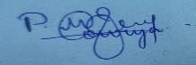

**Date:**

**Place:** Tekkali

P. Mourya